Final Memo
This final analysis aims to detect and reduce e-commerce delivery fraud at Walmart by analysing delivery data from Central Florida. The goal is to identify patterns indicating items marked as delivered but not received by customers. The findings will help create a model to minimize theft and fraud across all U.S. regions.
With our research, we could find crucial insights for higher stakeholders, facilitating the process of decision-making. In this memo, we’ll only display charts and conclusions we found while treating and analysing the data provided by the company. Later, we’ll also recommend next research with the aim to get more data and, consequently, better analysis with more accurate insights.

Recommendation 1
While analysing the total lost per region, we could identify an interesting pattern. The regions of Orlando, Altamonte Springs and Winter Park are responsible for almost 50% of our total losses. These three areas are what we considered “critical regions”.
In the chart below we can see the result of our analysis:
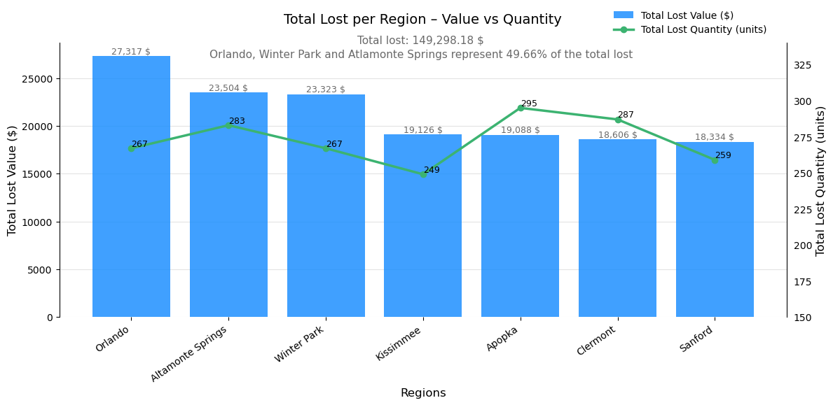
With this visualization, the company should focus more of its focus on these top 3 areas, considering them a tier 1 priority. In those areas, we recommend the company to enforce the next recommendations.

Recommendation 2
During our EDA process, we segmented drivers and customers using a method of score. The highest the score, the riskier the customer/driver. Our score rules were:
- Recurrency based of average: If the customer/driver had a higher number of incidents with lost packages, it would receive 1 point of fraudulence probability.
- Total Lost: To categorize the drivers/customers we found a standard value located at the 2nd and 3rd quartile (50%). For the customers, the value was 60$ and for the customers the value was 105$.
- Average Loss Ticket: To categorize the drivers/customers we found a standard value located between the 2nd and 3rd quartiles (50% and 75%). For both, the value was 60$.
In the chart below, we can see the distribution of fraudulent drivers around Orlando state:
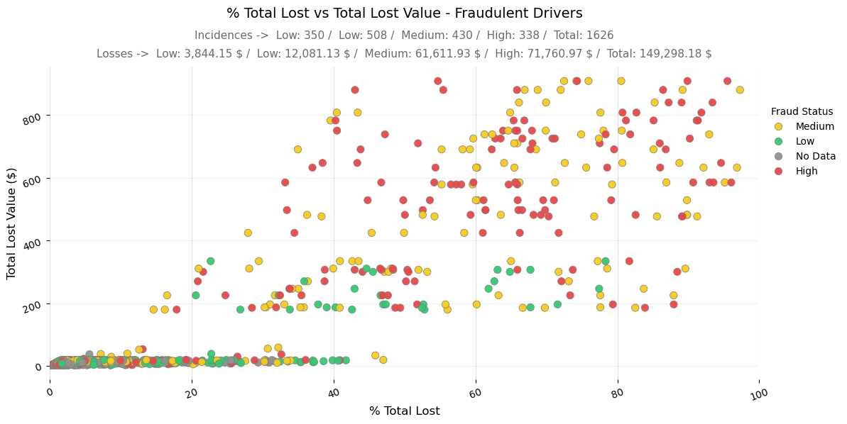
In this other chart, we can see the distribution of fraudulent customers around Orlando state:
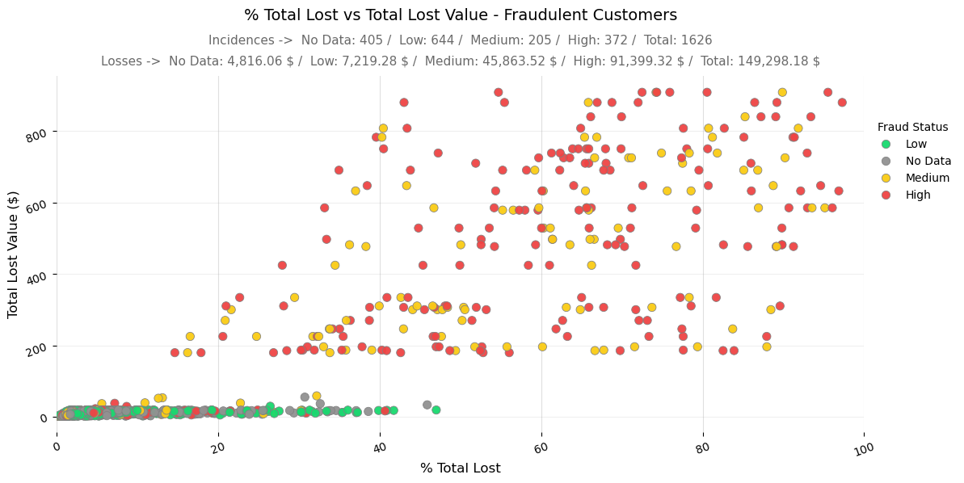
The company should completely ignore losses caused by the “No data” and “Low” categories for both drivers and customers, as these cases account for approximately 83% of total incidents but represent only 11% of total losses. Another important action to take is to create a methodology to not allow drivers with high fraudulent status to deliver high value orders.
We also recommend the company to start a Machine Learning project with the goal of categorizing more clients and customers, with the goal of segmenting them more precisely.

Recommendation 3
Our third recommendation is based on research done with the total lost during the hours of the day. In the following chart, it’s possible to see the pattern we found: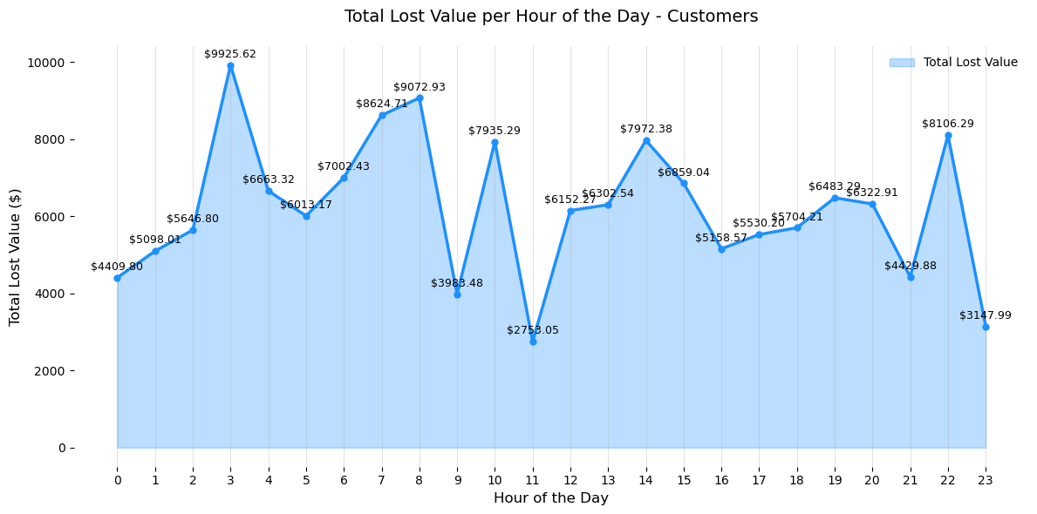
There is no precise recommendation for this single chart, once it’s to general and has no visible pattern. We recommend the company to analyse better the Power BI dashboard. There, the company can analyse the distribution of total loss per hours of the day segmented by region. Here are a few examples:
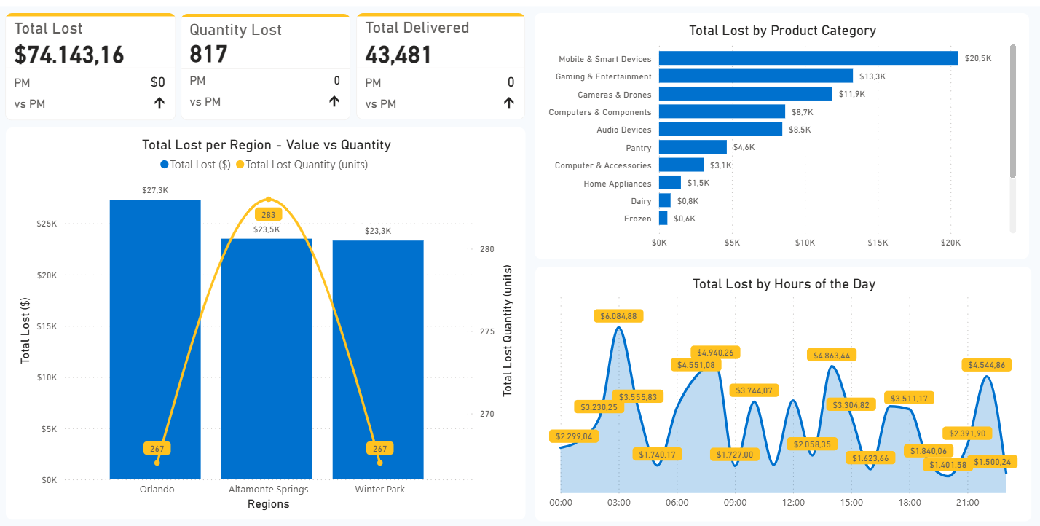
In the 3 critical regions, we see a distribution with peaks at 03:00 – 09:00, 12:00 – 15:00 and 21:00 – 00:00.
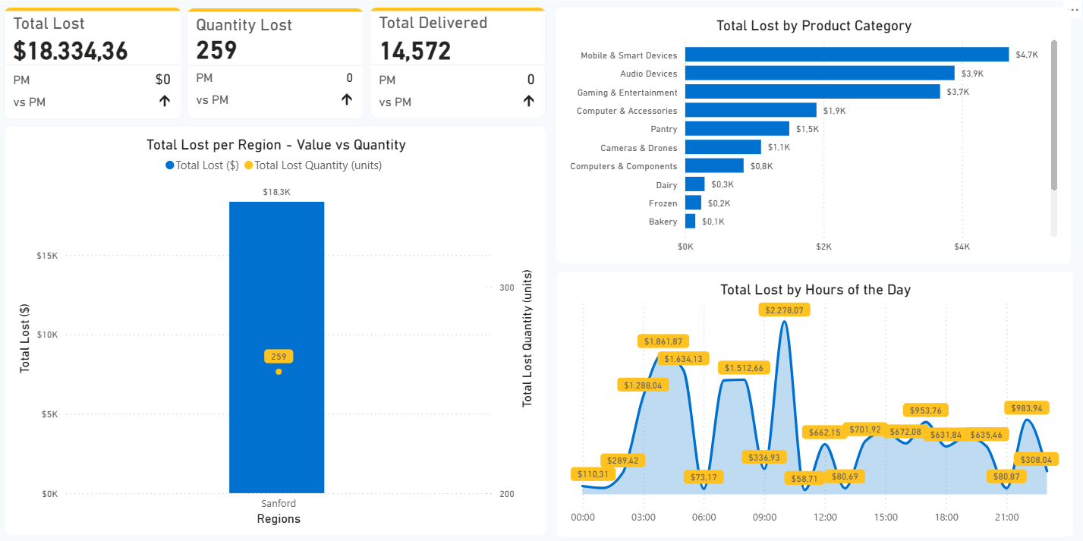
For the region of Sanford, we see a different behaviour. In this specific region, the critical hours are from 03:00 to 10:00.
In general, we recommend that the company increase security measures during the periods from 03:00–10:00, 13:00–15:00, and 20:00–00:00, as these are the time windows in which most fraud incidents occur.

Recommendation 4
While analysing the total lost per product category, we could identify important pattern in the chart below:
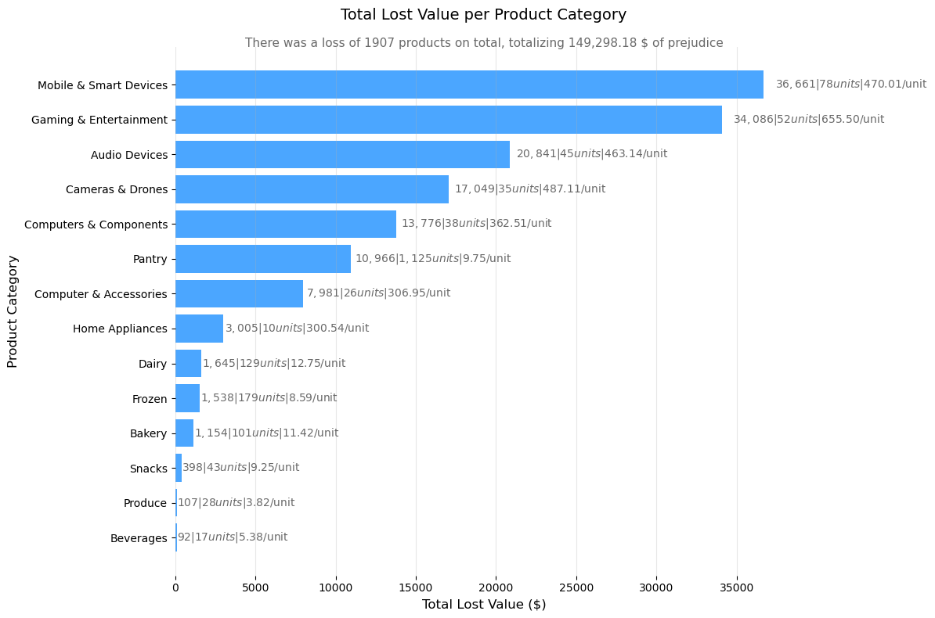
- The Pantry category accounts for 59% of the total quantity lost yet represents only 7.3% of the total loss value.
- The Gaming & Entertainment category contains the highest-value items, with an average loss of $655.50 per product.
- Mobile & Smart Devices represent the largest share of total losses, amounting to $36,661, or 24.55% of the overall loss value.
- The Electronics (“Mobile & Smart Devices”, “Gaming & Entertainment”, “Audio Devices”, “Cameras & Drones”, “Computer & Components” and “Computer & Accessories”) category contributes to 87.33% of the total loss value, despite representing only 14.3% of the total quantity lost.
With that, we highly recommend the company to concentrate its efforts on preventing the fraud on electronic items, increasing their bureaucracy of delivery and adding more layers of confirmations.

Conclusion
This analysis demonstrates that e-commerce delivery fraud in Central Florida is concentrated at some point in 3 areas, both geographically and operationally, rather than evenly distributed across regions, customers, drivers, time periods, and product categories. By identifying Orlando, Altamonte Springs, and Winter Park as critical regions responsible for nearly half of total losses, the study highlights where targeted interventions can generate the greatest impact.
The segmentation of drivers and customers further shows that a small group of high-risk profiles accounts for a disproportionate share of financial losses, while most incidents classified as “No data” or “Low” risk contribute minimally to total loss value. This finding supports the decision to focus resources on high-impact cases without compromising operational efficiency or customer experience.
Temporal and product-level analyses reinforce this targeted strategy. Fraud incidents cluster within specific time windows and are strongly associated with high-value electronic products, which represent most total losses despite a low share of total quantity. Together, these patterns suggest that enhanced controls, such as stricter delivery verification, increased monitoring during critical hours, and reinforced procedures for high-value items, can substantially reduce losses.
For future analysis, we recommend that the company initiate a machine learning project focused on segmenting customers and drivers based on criticality levels, with the objective of improving segmentation efficiency. Additionally, we recommend expanding data collection efforts for customers and drivers classified as “High” and “Moderate” risk, enabling a subsequent people analytics project. This future initiative would aim to deepen individual-level classification, reduce the risk of unfair or biased categorizations, and support more granular and accurate analytical insights.

